**Ewart Oakeshott – A Knight and His Weapons**

# Spear and Lance

* There is little variation in the shape of a spearhead. Forms in use when Pharaoh’s power dominated the lands of the Eastern Mediterranean are similar to the ones popular when Queen Victoria’s power dominated India, and in the 3,000 years in between we find many forms constantly repeated from Wales to Japan and from Finland to Morocco.
* In ancient Greece (from about 600 B.C. to 120 B.C.), one way of using the spear on foot was to hurl it from a distance of only a few feet. A warrior tried to hit his enemy in the midriff. As the warrior threw, he ran in; his foe doubled up over the spear in his stomach as the warrior finished him with a strong sword-stroke to the back of the neck as the foe went forward. If the warrior missed with is first throw, he might be lucky enough to cast his second spear and get his enemy with that.
* The Romans developed a very specialized form of throwing-spear for this purpose, called a pilum. Its head was small and leaf-shaped, set on a very long iron neck which ended in a hollow socket into which the shaft of ash or acacia woods was set (fig below) The reason for the slender iron neck below the head was this: when the legionary engaged with a foe, he flung his pilum as he advanced. If it hit the foe’s shield the spear stuck into it, but the iron haft ben downward. The unlucky foe would have to cope with a heavy bent spear dragging his shield down. Of course, the simplest and best solution would have been to hack off the stuck spear near the head with an axe or sword, but the iron neck made this impossible. This spear type was adopted by the Franks and Anglo-Saxons, who called it an angon, and they used it in precisely the same way, to deprive their enemy of the use of his shield – if, of course, they did not get through or behind the shield to wound or kill him.



* The spear was used by foot-soldiers during all the long centuries between the time of the Sumerians of about 3000 B.C. and the end of the Thirty Years’ War in Europe in A.D. 1648. Sumerian and Egyptian foot-soldiers used a broad-bladed weapon about six feet long; they fought with it like a bayoneted rifle, in disciplined bodies of infantry acting in close formation and charging in line. The same sort of weapon was used by the Franks, Saxons, and Vikings, and by the Scots at Bannockburn in 1314 and by the French at Poitiers in 1356, as well as by the professional Welsh and Brabancon spearmen in the armies of the fourteenth and fifteenth centuries. The head of this spear – whether it was used by the infantry of Pharaoh, Themistocles, Sweyn Forkbeard, Robert Bruce, or Charles the Rash – was of the same shape: about ten to twelve inches – with a strong rib running up the middle. In the Middle Ages, particularly during the eighth and ninth centuries, and again in the fifteenth, the spear was often furnished with wings or lugs below the head, made as part of the socket. This broad spear could be used as both a cutting and a thrusting weapon.

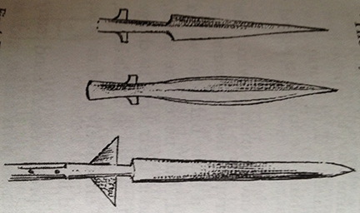

* Another specialized form of infantry spear was the pike, purely a thrusting weapon with a different shaped head set on an extremely long shaft, often as much as eighteen feet long. This head was small and narrow, only about six inches long and hardly broader than the shaft behind it. The pike was first used in ancient Greece in the armies of Macedon about 300-120 B.C. and was developed – or rather, its tactical use was developed – by the ruler of that land, Philip, father of Alexander the Great. It dominated the art of war in those areas of the Middle East conquered by Alexander until in 168 B.C. it met the Roman legions at Pydna. Here the pilum and short sword in the hands of the tough legionaries completely overcame the pike, and we hear no more of it until the Swiss reintroduced it during the 15th century A.D. Then, like the ancient Macedonians, they dominated the 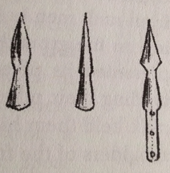battlefields of Europe with it until, in a great and bloody battle at Bicocca in Nortner Italy in 1522, they were decisively beaten by the firepower of the newly perfected arquebus.

The reason for the great length of the pike was so that three or even four ranks of the column could have their pike-heads projecting in front: the front-rank men held their pikes low, the butt resting on the ground behind them; the second rank presented its pikes between the front-rank men, holding their pikes level, while those in the third rank held them high and presented them over the shoulders of the front-rank men. The ranks behind held their pikes upright, ready to step forward and take the place of men who fell in the leading ranks. Thus arrayed, the whole column, often about 2,000 men, rolled irresistibly forward. Until it became possible to thin out these columns with cannon and arquebus fire before they came to close quarters, nothing could stand before them except another column of pikes. Then came the “push of pikes,” when the two columns, locked together, pushed at each other like linemen in a football game until one or the other gave way.

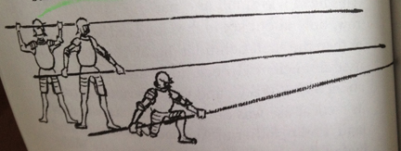

* These infantry weapons, though used for a long time, had little effect on the course of medieval battles, which were usually decided by the heavy cavalry – the men-at-arms and the knights. But early in the fourteenth century the halberd, newly developed by the Flemings and the Swiss, had a great deal of influence on the development of the armor these men-at-arms and knights wore. In two battles, at Courtrai in Flanders (1302) and Morgarten in Switzerland (1315), large forces of splendidly equipped cavalry were terribly defeated by townsmen and peasants armed with halberds.
* At Courtrai the best of France’s knighthood armed with lance and sword and protected by mail reinforced at the knee and shoulder with iron plate, and with coats of plates under their surcoats, made a series of gallant but badly organized charges across a stream against a solid mass of Flemings. Two things happened that the French knights did not expect. First, the townsmen stood firm and did not break and run before the proud trampling horses. Second, the mounted charges got bogged down in the muddy meadow between the stream and the Fleming’s position; while they were floundering about trying to get up speed to charge the enemy ranks, the Flemings themselves took the initiative and charged the knights who were at such a disadvantage. The halberds (these Flemings called them godendags – “good mornings”) cut through the knightly mail and clove shield and helmet as a knife goes through better.

It was the French knights who broke and tried to run, but they had to struggle through the muddy field with the stream at its bottom. In panic and disorder they crowded down to the water. Those who reached it first tried to rein in and move aside to find a shallower place to cross, but they were pushed down the slippery bank by the crowds pushing behind; in they plunged, drowning by the hundreds in the muddy water.

* At Morgarten a similar thing happened. The reasons for the battle are too complicated to go into in detail here. But, in brief, it began because in 1314 two rival emperors had been elected to the throne of the Holy Roman Empire, and one of the cantons of Switzerland, Schwyz, had decided to make use of the confusion to break away from the Empire and become independent. The brother of one of the emperors, Duke Leopold of Austra, was sent with a force of knights to bring the Schwyzers back to their allegiance. So one November day in 1314, this force was making its way through the mountains to come at this upland country. The Schwyzers had blocked all the roads save one, and along this the Austrians came, foolishly confident and unprepared. The road wound between a steep hillside and a small lake, and where the space between hill and lake was narrowest the Schwyzers blocked this road too, and set an ambush on the wood-crowned hill above. They cut a lot of the tree-trunks, and trimmed the branches off close so that they would roll. Then they waited.